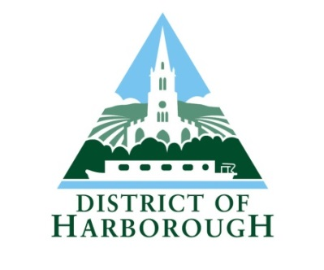
PARISH COMMUNICATION SURVEY FOR 2016-2017

Each year we ask all Harborough Parishes to complete our Parish Communication Survey. If you could please complete this and return before 10th March 2017, that would be greatly appreciated.

YOUR PARISH:………………………………………………………………………………………………………

COMPLETED BY:……………………………………………………………………………………………………….

- How do you rate general communication from HDC over this last year? (please tick one box)

Very Poor | Poor | Satisfactory | Good | Excellent

- To what degree, on a scale of one to ten, do you feel that Harborough District Council keeps you informed about matters of Parish Interest, in general (please tick one box)

1  Extremely badly | 2 | 3 | 4 | 5 | 6 | 7 | 8 | 9 | 10  Extremely Well

- To what degree do you rate your general working relationship with the District Council? (please tick one box)

Very Poor | Poor | Satisfactory | Good | Excellent

- How do you rate your liaison with each of the following HDC Officers/areas:

  - Parish Liaison

Very Poor | Poor | Satisfactory | Good | Excellent

  - Planning

Very Poor | Poor | Satisfactory | Good | Excellent

  - Finance

Very Poor | Poor | Satisfactory | Good | Excellent

  - Customer Services

Very Poor | Poor | Satisfactory | Good | Excellent
  - Elections and Electoral Registration

Very Poor | Poor | Satisfactory | Good | Excellent

g. Waste and Street Cleansing

Very Poor | Poor | Satisfactory | Good | Excellent

h. Enforcement (please give a scoring for each area of enforcement)

 | Very Poor | Poor | Satisfactory | Good | Excellent
Planning Enforcement
Dog Fouling
Fly Tipping
Car Parking
Antisocial Behaviour
Noise
Graffiti
Bonfires/Pollution

5. Development Management:
Does the Parish Council want to continue to receive a paper copy of the planning application site notice? (please tick one box)

Yes | No

Does the Parish Council want to continue to receive paper copies of plans and information in connection with planning applications? (please tick one box)

Yes | No

- Please tell us how HDC Officers can continue to improve our working relationship with parishes?
…………………………………………………………………………………………………………………………………………………………………………………………………………………………………………………………..
……………………………………………………………………………………………………………………………
- How do you rate the Harborough District Council website (www.harborough.gov.uk) with regards to enabling you to find out information for your Parish Meetings/Councillors/ Residents? (please tick one box)

Not as Good | No Change | Satisfactory | Much Better | Excellent

- The Council has recently introduced an electronic newsletter for all residents which will be published at least four times a year. This is automatically emailed to all parishes on our database from the Council’s Communications Team. How often do you read this? (please tick one box)

Never | Rarely | Occasionally | All the time

- A number of parishes have reported that, despite the initial inertia associated with introducing Social Media as a communication tool for their parish, once in place, it has proved invaluable. The District Council uses Twitter, Facebook and LinkedIn daily to share news.

- Would your parish be interested in being offered support to enable you to introduce social media as a Parish Communication Tool? (please tick one box)

No | Maybe | Yes | Already use it

Thank you for taking the time to complete our survey

Please return electronically to n.hankin@harborough.gov.uk or by mail to Nada Hankin, Harborough District Council, Adam and Eve Street, Market Harborough, Leicestershire, LE16 7AG.

